Computer Systems Architecture

Lab 08

Submitted By: Feisal Salim Wenzhong Zheng

Submitted To: Maryam Davoudpour

**Description**

In the virtual CPU project as of now, Implemented the registries to be used with a functional program counter which increments every 4 bits which corresponds to each instruction.

**screenshots of output**

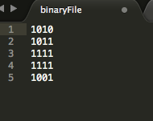

The Data to be executed.

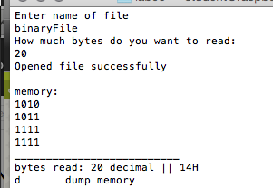

Loading the binary File into memory.

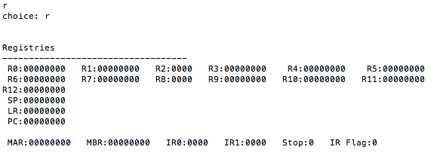

the r choice displays the registries at the moment.

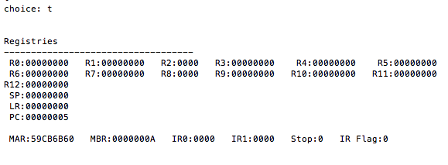

The trace command executes first instruction as PC increases and value stored in MBR. The address of the command executed is also in the MAR.

**Source code will be attached.**